**Sponsorship**

Dashboard  
  
- Total Sponsorship (This Month)

* Total Bottles sponsored. (This Month)
* On-going Sponsored event (This Month)
* Sponsorship need to be approve

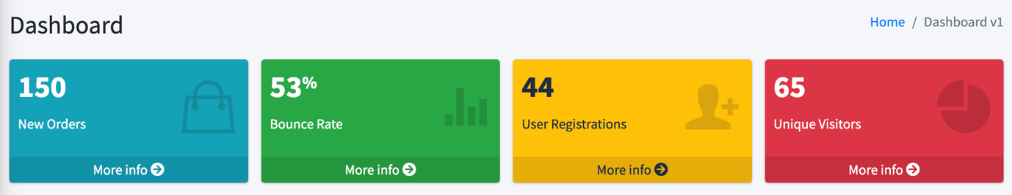

Report

Total Sponsored event Report (Year)

* Black listed, Total , ongoing

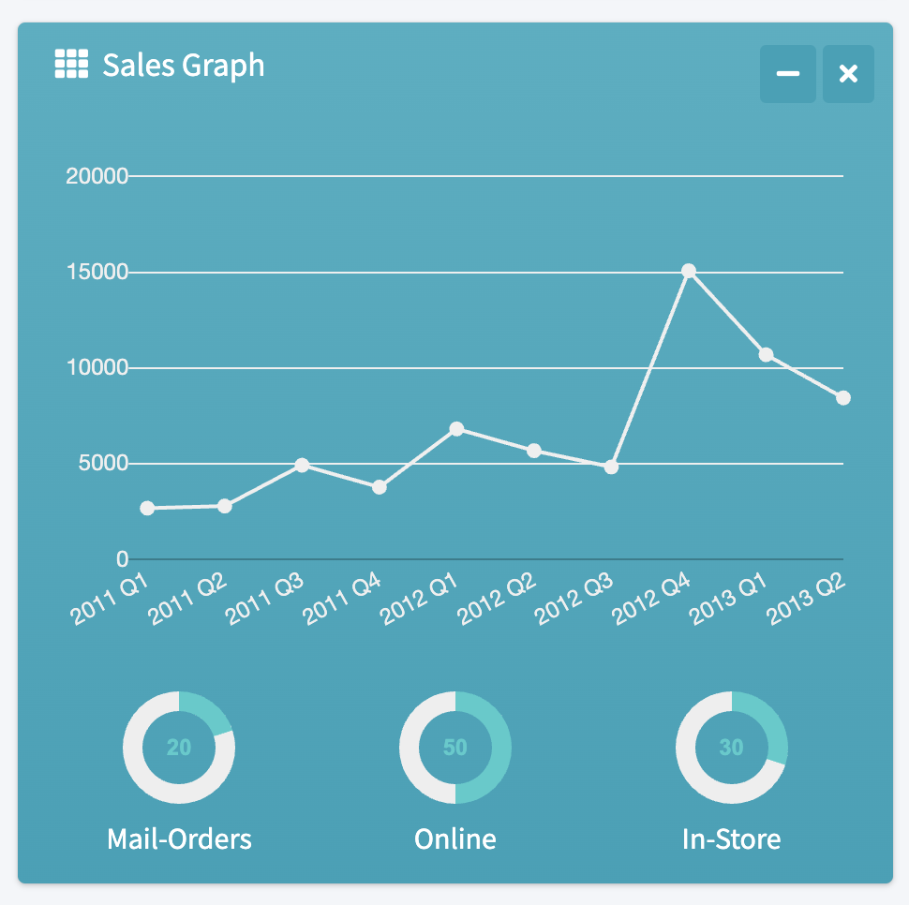

All Sponsorship List

- Submitted Date

* Event Name
* Event Date
* Status
* Total Sponsor Bottles

Recently Submitted Event Photo  
- Event title  
- Event Date  
- Event submitted date

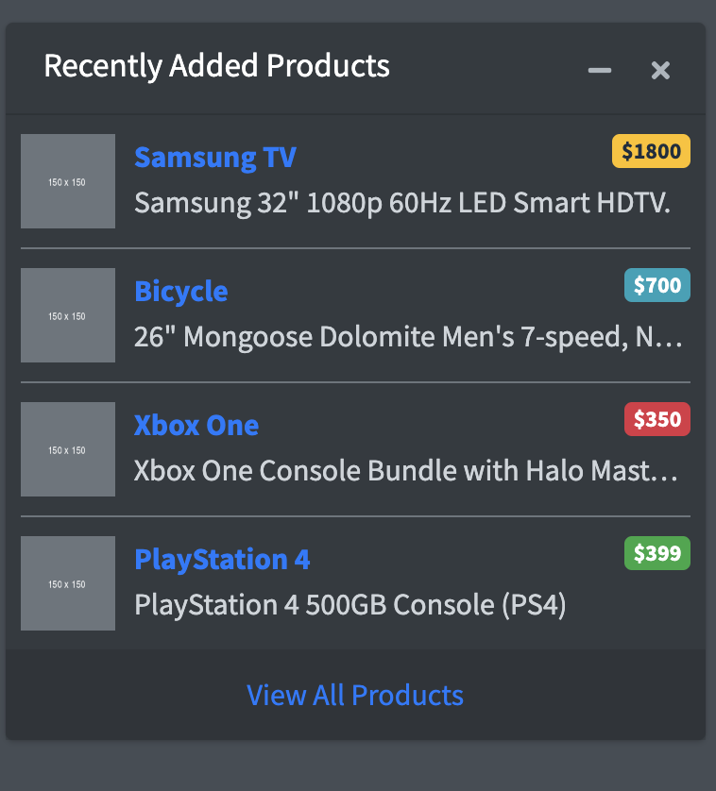

Calendar

